**EXPERIMENT:12**:

**Aim:** Demonstrate Infrastructure as a Service (IaaS) by creating a resources group using a Public Cloud Service Provider (Azure), configure with minimum CPU, RAM, and Storage.

**Implementation:**

STEP:1:: open azure and create account Go to resource groups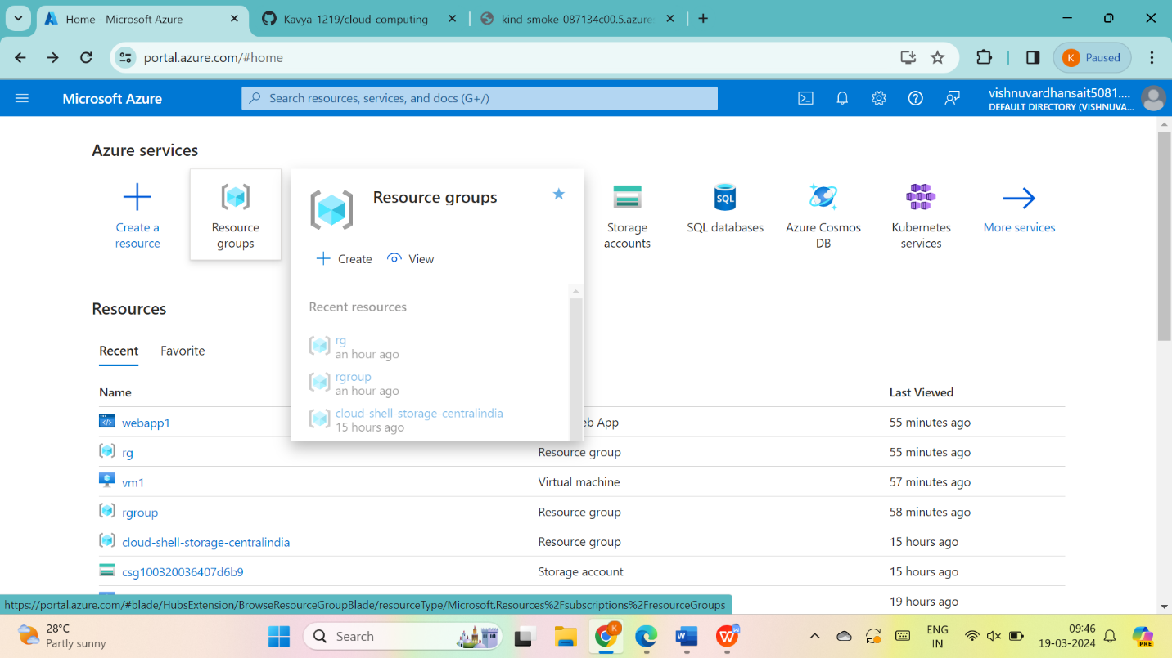

THEN GO THE CREATE. 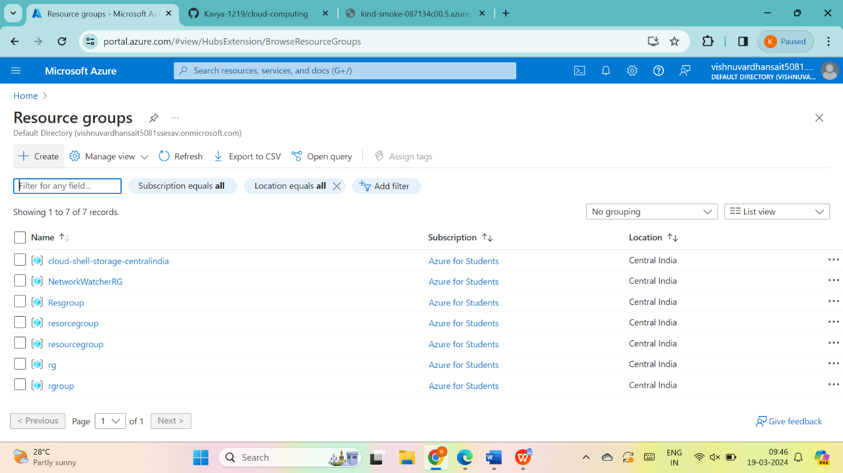

Give name to resource group and give next:tages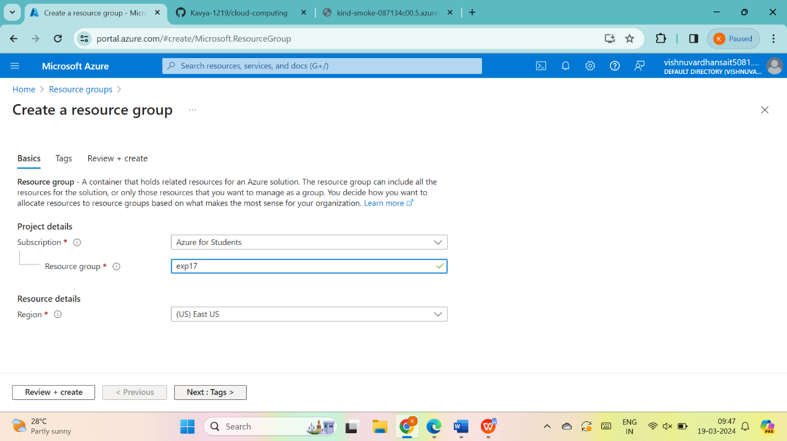

Fill the name and value and give next:review+create>

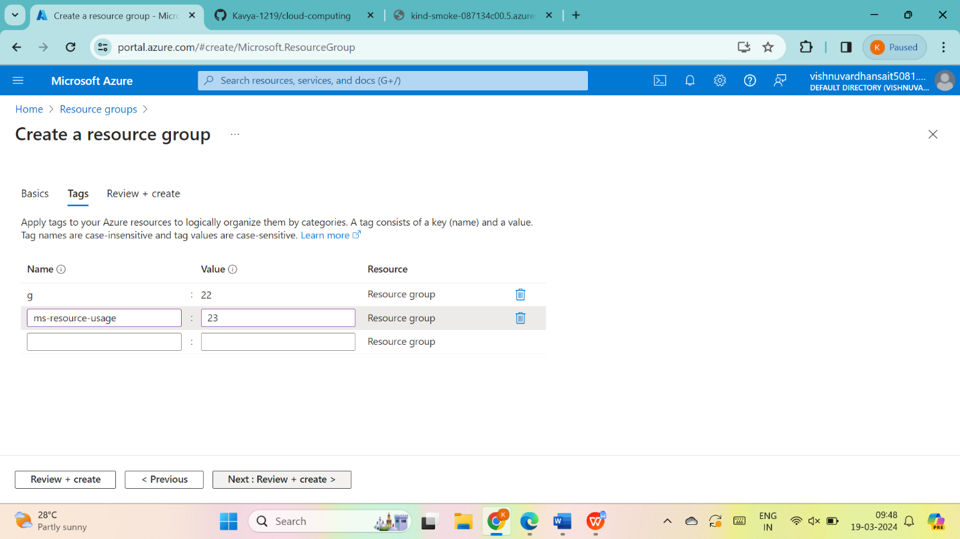

STEP:3:: go to create

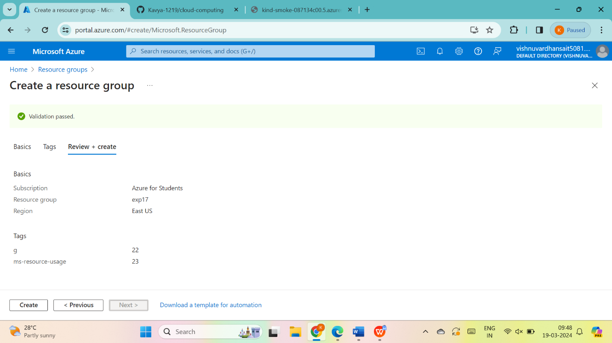

STEP:4:so the resource group was created then go to resource group

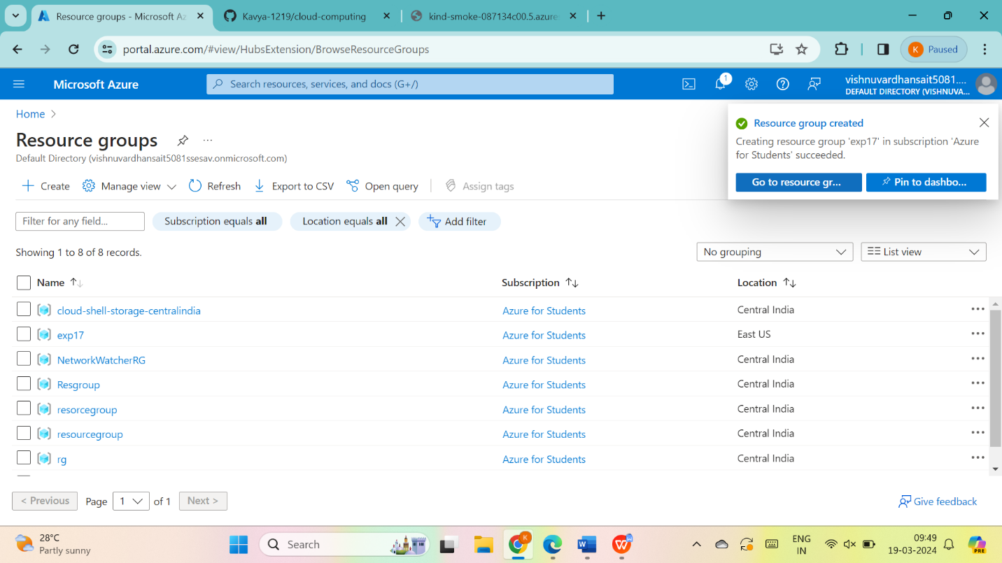

RESULT: THUS,THE PROGRAM FOR THE RESOURCE GROUP IN AZURE HAS BEEN DONE SUCCESSFULLY



